VirtualEye - Life Guard for Swimming Pools to Detect Active Drowning

1. INTRODUCTION
1. Project Overview
2. Purpose
2. LITERATURE SURVEY
1. Existing problem
2. References
3. Problem Statement Definition
3. IDEATION & PROPOSED SOLUTION
1. Empathy Map Canvas
2. Ideation & Brainstorming
3. Proposed Solution
4. Problem Solution fit
4. REQUIREMENT ANALYSIS
1. Functional requirement
2. Non-Functional requirements
5. PROJECT DESIGN
1. Data Flow Diagrams
2. Solution & Technical Architecture
3. User Stories
6. PROJECT PLANNING & SCHEDULING
1. Sprint Planning & Estimation
2. Sprint Delivery Schedule
7. CODING & SOLUTIONING
1. Features
8. TESTING
1. User Acceptance Testing

1.Introduction:
1.1 Project overview:-
The death from drowning has caused one third of untimely death in the world. This happens to small children and newbie swimmers to prevent this from happening there are various safety measures taken to prevent drowning in swimming pool. The spatial relationship between the location information of the target and swimming/drowning area of swimming pool is analyzed to further determine the swimmer’s drowning or swimming behavior. This paper compares the detection accuracy of different detection algorithms and analyzes the detection effect of different pool angles and different swimmer densities.

1.2 Purpose
Drowning detection in dynamic swimming environments is a challenging problem in computer vision, for which no satisfiable solutions have been found. Currently known methods primarily rely on background subtraction-based techniques; however, random motion caused by water rippling, splashing, and moving reflections frequently result in interference and inaccuracies. It is mainly used to prevent drowning and rescuing the victim in golden hour.

2.Literature Survey:

2.1 Existing problem
There are various drowning detection available nowadays, which helps people who are drowning but with these detection mechanism can cause hindrance while swimming. The newbie swimmers, children will find it difficult to swim and may cause drowning while swimming.
Swimming is one of the exercises done by modern people to relieve stress from their daily life. But the unplanned death from drowning is in the third place in the world. There is a need to find a solution to this problem. In Project - VirtualEye - Life Guard for Swimming Pools to Detect Active Drowning we find solution to this problem by detecting active drowning with the help of live feeds to alert the lifeguard. The novice swimmers, children find it hard to breath underwater and are not accustomed to swimming like veteran swimmers this causes a lot of drowning incident. Even if the lifeguard are on their toes it is easy to miss details of drowning. This causes us to lose our loved ones. In this system we detect the objects in the swimming pool with the help of cameras. The swimming pool is recorded with the cameras and the live feed is used to detect drowning and give alert to the lifeguard. This helps the lifeguard to take action as soon as he/she gets the alert. Here we use YOLO algorithm to train our model to identify the active drowning movements. For this purpose we train our model to detect objects and then to identify drowning movements with the help of images and videos which helps to identify drowning movements in real time. This system assures public to have a safe and secure time of swimming and help the lifeguard to save lives without any regrets.

2.2 Reference
Project description from dashboard, https://www.thewirh.com/blog/dds-how-do-they-work Artificial Intelligence usecases, AngelEye, SwimEye .

2.3 Problem Statement Definition
When a newbie swimmer, parent of a child wants a safe, hassle free environment and to stress about drowning and to have a pleasant environment during the swimming space it is necessary to use some preventive measures. This system uses the surveillance camera to detect whether the person is drowning or not.

3.Ideation and Proposed solution
3.1 Empathy Map Canvas
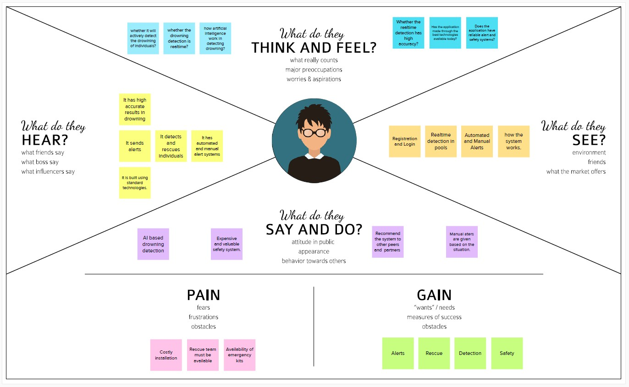
3.2 Ideation and Brainstorming
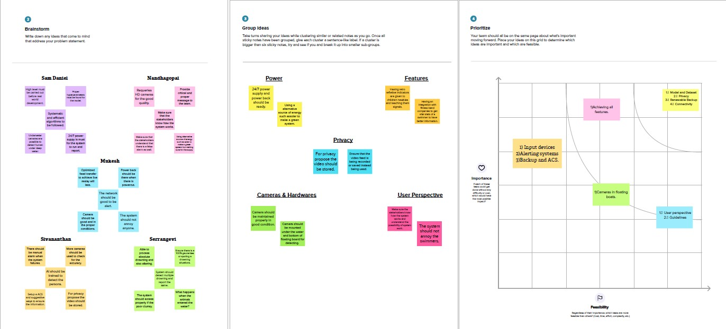

3.3 Proposed Solution
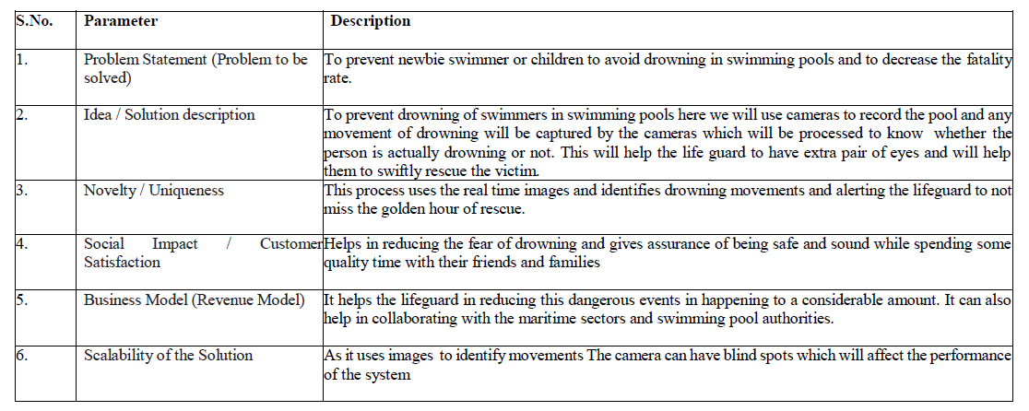
3.4 Problem Solution Fit
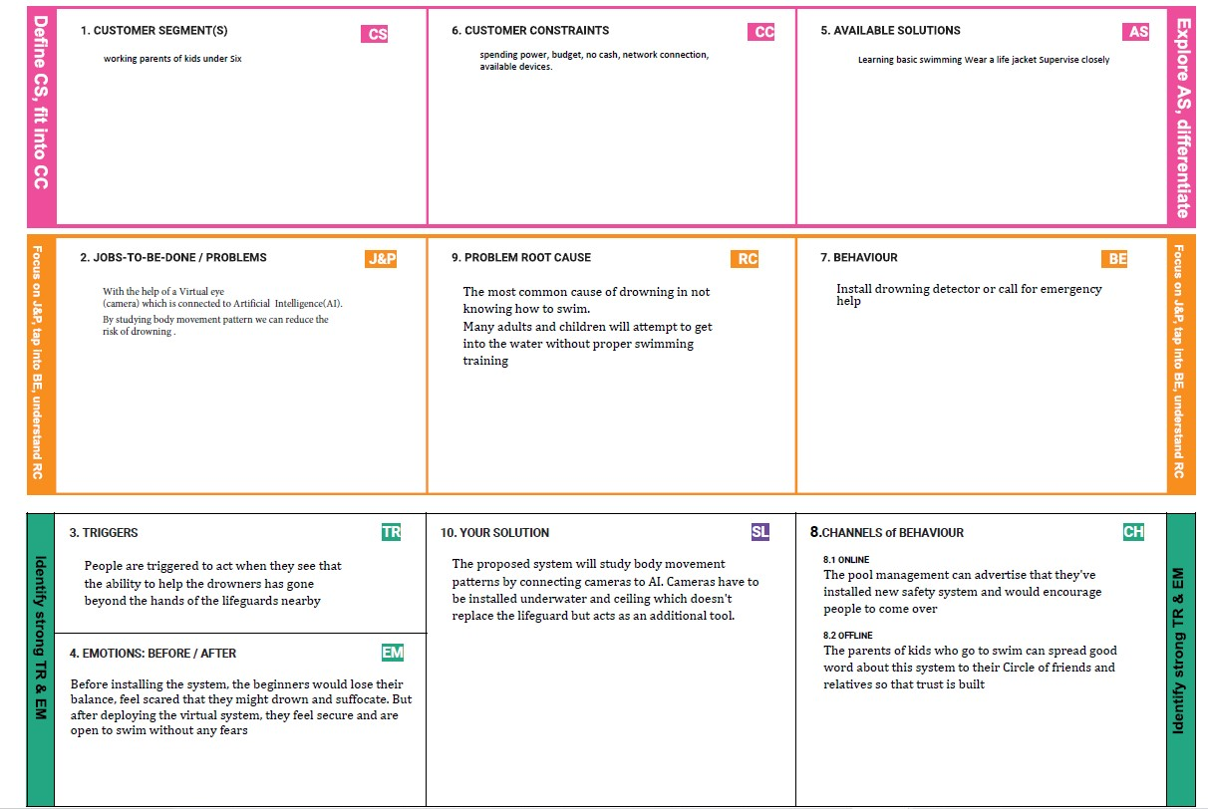

4.Requirement Analysis :
4.1 Functional requirements
Following are the functional requirements of the proposed solution.
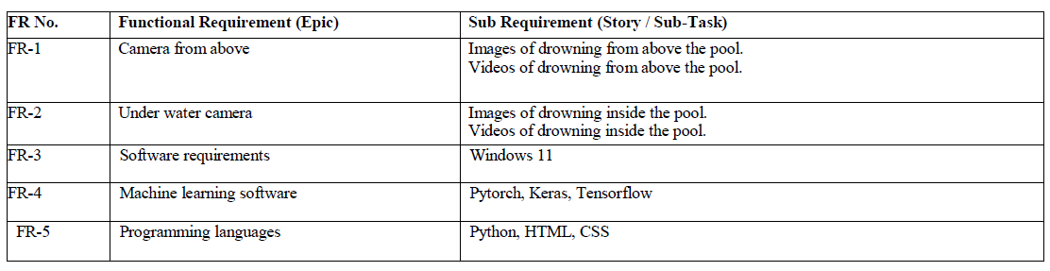
4.2 Non Functional requirements
Following are the non-functional requirements of the proposed solution.
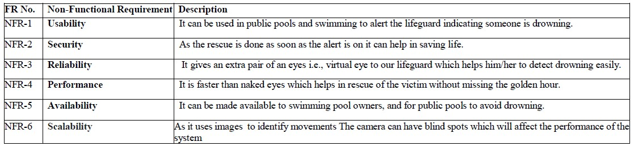
5.Project Design:
5.1 Data Flow Diagrams
A Data Flow Diagram (DFD) is a traditional visual representation of the information flows within a system. A neat and clear DFD can depict the right amount of the system requirement graphically. It shows how data enters and leaves the system, what changes the information, and where data is stored.
5.2 Solution and Technical Architecture
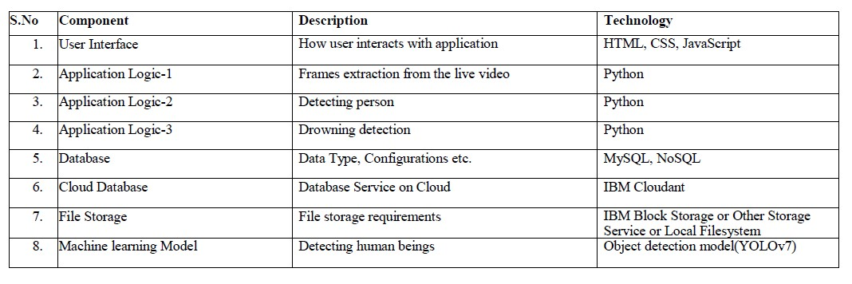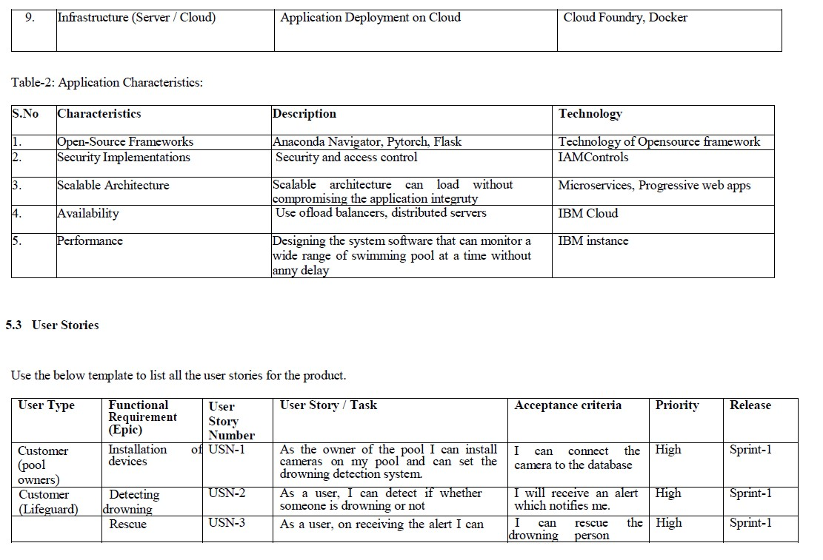
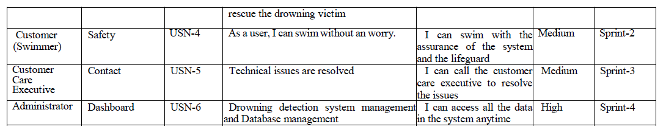
6.Project planning and Scheduling :
6.1 Sprint Schedule and Estimation
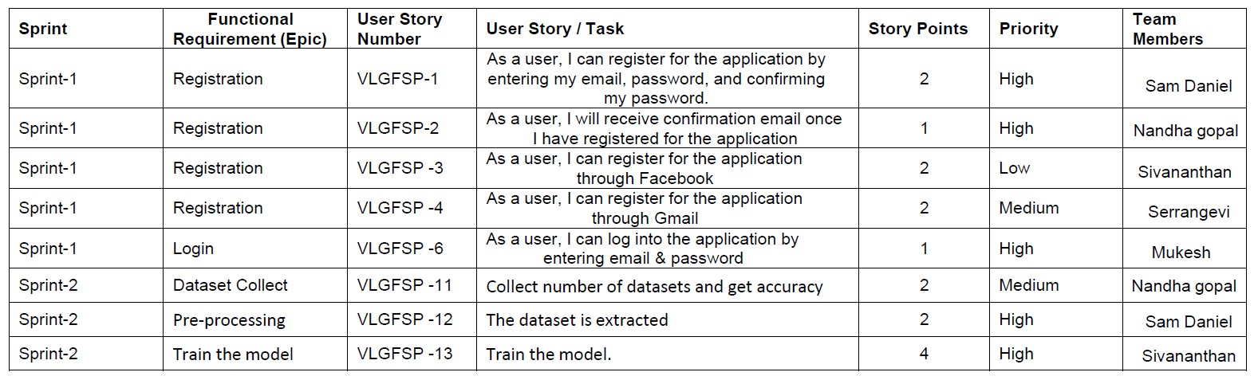
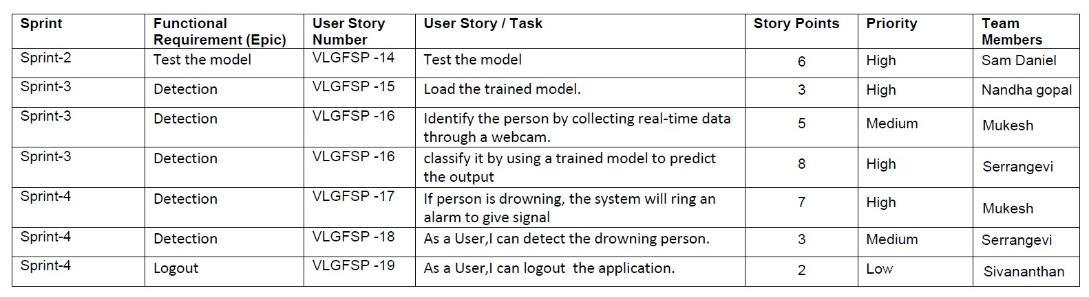
6.2 Sprint Delivery Schedule
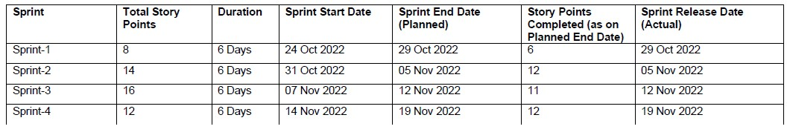
7.Coding and Solution
7.1 Html pages
Case1: Index page
In this page we will see the home page of our website where there will be options to register into the application, login into the application, see the prediction of the application and know about our application.
Case2: Register page
We can register into the account using this page, by using our credentials we can register our account in the application.
Case3: Login page
In this page with the credentials we used to register we can login into our account to try the demo of our project

Case4: Prediction page
This page helps in showcasing our demo of the project. On clicking the button for demo we can get the results in the project.

Case5: Logout page
In this page we can come out of our application by safely logging off our account.

8.Testing :
8.1 User Acceptance testing
1. Defect Analysis
This report shows the number of resolved or closed bugs at each severity level, and how they were resolved.
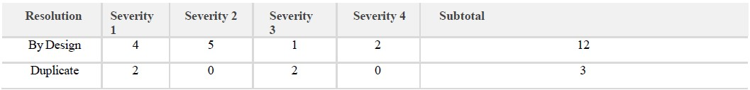
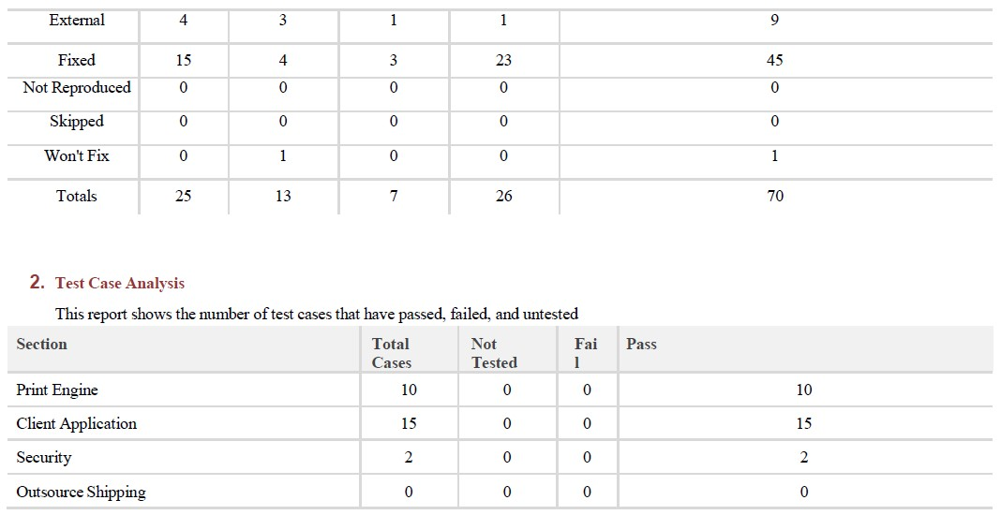

9. Conclusion
This system allows us to use the swimming pools without any worry and helps the lifeguard with an extra pair of eyes so that he/she can rescue people in a given time.
Source code:
final.css
.img-preview {
width: 256px;
height: 256px;
position: relative;
border: 5px solid #F8F8F8;
box-shadow: 0px 2px 4px 0px rgba(0, 0, 0, 0.1);
margin-top: 1em;
margin-bottom: 1em;
}
.img-preview>div {
width: 100%;
height: 100%;
background-size: 256px 256px;
background-repeat: no-repeat;
background-position: center;
}
input[type="file"] {
display: none;
}
.upload-label{
display: inline-block;
padding: 12px 30px;
background: #28272c;
color: #fff;
font-size: 1em;
transition: all .4s;
cursor: pointer;
}
.upload-label:hover{
background: #C2C5A8;
color: #39D2B4;
}
.loader {
border: 8px solid #f3f3f3; /* Light grey */
border-top: 8px solid #28272c; /* Blue */
border-radius: 50%;
width: 50px;
height: 50px;
animation: spin 1s linear infinite;
}
@keyframes spin {
0% { transform: rotate(0deg); }
100% { transform: rotate(360deg); }
}
Jscript.js
'use strict'
const demo = document.querySelector('#demo');
const imageUpload = document.getElementById('imageupload');
const dataAttributeEL = document.querySelectorAll(`div[data-type]`);
const displayAll = function () {
dataAttributeEL.forEach(el => {
el.classList.remove('hidden')
})
}
imageUpload.addEventListener('change', (event) => {
const fileList = event.target.files[0];
//console.log(URL.createObjectURL(fileList));
if (fileList) {
demo.src =URL.createObjectURL(fileList);
}
displayAll();
});
const prediction = document.querySelector('#result')
dataAttributeEL.forEach(el => {
if (el.dataset.type !== prediction.innerHTML.trim()) {
el.classList.add('hidden')
};
})
main.js
$(document).ready(function () {
// Init
$('.image-section').hide();
$('.loader').hide();
$('#result').hide();
// Upload Preview
function readURL(input) {
if (input.files && input.files[0]) {
var reader = new FileReader();
reader.onload = function (e) {
$('#imagePreview').css('background-image', 'url(' + e.target.result + ')');
$('#imagePreview').hide();
$('#imagePreview').fadeIn(650);
}
reader.readAsDataURL(input.files[0]);
}
}
$("#imageUpload").change(function () {
$('.image-section').show();
$('#btn-predict').show();
$('#result').text('');
$('#result').hide();
readURL(this);
});
// Predict
$('#btn-predict').click(function () {
var form_data = new FormData($('#upload-file')[0]);
// Show loading animation
$(this).hide();
$('.loader').show();
// Make prediction by calling api /predict
$.ajax({
type: 'POST',
url: '/predict',
data: form_data,
contentType: false,
cache: false,
processData: false,
async: true,
success: function (data) {
// Get and display the result
$('.loader').hide();
$('#result').fadeIn(600);
$('#result').text('Prediction: '+data);
console.log('Success!');
},
});
});
});
Index.html
<!DOCTYPE html>
<html lang="en">
<head>
<meta charset="UTF-8">
<meta http-equiv="X-UA-Compatible" content="IE=edge">
<meta name="viewport" content="width=device-width, initial-scale=1.0">
<!--Bootstrap -->
<link rel="stylesheet" href="https://maxcdn.bootstrapcdn.com/bootstrap/4.0.0/css/bootstrap.min.css" integrity="sha384-Gn5384xqQ1aoWXA+058RXPxPg6fy4IWvTNh0E263XmFcJlSAwiGgFAW/dAiS6JXm" crossorigin="anonymous">
<script src="https://code.jquery.com/jquery-3.2.1.slim.min.js" integrity="sha384-KJ3o2DKtIkvYIK3UENzmM7KCkRr/rE9/Qpg6aAZGJwFDMVNA/GpGFF93hXpG5KkN" crossorigin="anonymous"></script>
<script src="https://cdnjs.cloudflare.com/ajax/libs/popper.js/1.12.9/umd/popper.min.js" integrity="sha384-ApNbgh9B+Y1QKtv3Rn7W3mgPxhU9K/ScQsAP7hUibX39j7fakFPskvXusvfa0b4Q" crossorigin="anonymous"></script>
<script src="https://maxcdn.bootstrapcdn.com/bootstrap/4.0.0/js/bootstrap.min.js" integrity="sha384-JZR6Spejh4U02d8jOt6vLEHfe/JQGiRRSQQxSfFWpi1MquVdAyjUar5+76PVCmYl" crossorigin="anonymous"></script>
<script src="https://kit.fontawesome.com/8b9cdc2059.js" crossorigin="anonymous"></script>
<link href="https://fonts.googleapis.com/css2?family=Akronim&family=Roboto&display=swap" rel="stylesheet">
<link rel="stylesheet" href="../static/style.css">
<!-- <script defer src="../static/js/main.js"></script> -->
<title>Virtual Eye</title>
</head>
<body>
<header id="head" class="header">
<section id="navbar">
<h1 class="nav-heading"></i>Virtual Eye</h1>
<div class="nav--items">
<ul>
<li><a href="{{ url_for('index')}}">Home</a></li>
<li><a href="{{ url_for('login')}}">Login</a></li>
<li><a href="{{ url_for('register')}}">Register</a></li>
<li><a href="{{ url_for('login')}}">Demo</a></li>
</ul>
</div>
</section>
<section id="slider">
<div id="carouselExampleIndicators" class="carousel" data-ride="carousel">
<ol class="carousel-indicators ">
<li data-target="#carouselExampleIndicators" data-slide-to="0" class="active "></li>
<li data-target="#carouselExampleIndicators" data-slide-to="1"></li>
<li data-target="#carouselExampleIndicators" data-slide-to="2"></li>
</ol>
<div class="carousel-inner">
<div class="carousel-item active">
<img class="d-block w-100" src="../static/img/1.png" alt="First slide">
</div>
<div class="carousel-item">
<img class="d-block w-100" src="../static/img/second.jpg" alt="Second slide">
</div>
<div class="carousel-item">
<img class="d-block w-100" src="../static/img/third.jpg" alt="Third slide">
</div>
</div>
<a class="carousel-control-prev" href="#carouselExampleIndicators" role="button" data-slide="prev">
<span class="carousel-control-prev-icon" aria-hidden="true"></span>
<span class="sr-only">Previous</span>
</a>
<a class="carousel-control-next" href="#carouselExampleIndicators" role="button" data-slide="next">
<span class="carousel-control-next-icon" aria-hidden="true"></span>
<span class="sr-only">Next</span>
</a>
</div>
</section>
</header>
<section id="about">
<div class="top">
<h3 class="title text-muted">
ABOUT PROJECT
</h3>
<div class="line"></div>
</div>
<div class="body">
<div class="left">
<h2>Problem:</h2>
<p>
Swimming is one of the best exercises that helps people to reduce stress in this urban lifestyle. Swimming pools are found larger in number in the hotels, weekend tourist spots and barely people have in their house backyard. Beginners, especially often feel it difficult to breathe under water and causes breathing trouble which in turn cause a drowning accident. Worldwide, drowning produces a higher rate of mortality without causing injury to children. Children under six of their age are found to be suffering the highest drowning mortality rates worldwide..Such kinds of deaths account for the third cause of unplanned death globally, with about 1.2 million cases yearly.
</p>
</div>
<div class="left">
<h2>Solution:</h2>
<p>
To overcome the conflict, a meticulous system is to be implemented along the swimming pools to save the human life. By studying body movement patterns and connecting cameras to an artificial intelligence (AI)system we can devise an underwater pool safety system that reduces the risk of drowning. Usually such systems can be developed by installing more than 16 cameras underwater and ceiling and analysing the video feeds to detect any anomalies . but AS a POC we make use of one camera that streams the video underwater and analyses the position of swimmers to assess the probability of drowning ,if it is higher than an alert will be generated to attract lifeguards attention.
</p>
</div>
</div>
<div class="bottom">
<p ><b>
Note : The system is not designed to replace a lifeguard or other human monitor, but to act as an additional tool. “It helps the lifeguard to detect the underwater situation where they can’t easily observe.
</b></p>
</div>
</section>
<section id="footer">
<p>Copyright © 2021. All Rights Reserved</p>
<div class="social">
<a href="#" target="_blank"><i class="fab fa-2x fa-twitter-square"></i></a>
<a href="#" target="_blank">
<i class="fab fa-2x fa-linkedin"></i></a>
<a href="#">
<i class="#"></i>
</a>
</div>
</section>
</body>
</html>
Login.html
<!DOCTYPE html>
<html >
<head>
<meta charset="UTF-8">
<meta name="viewport" content="width=device-width, initial-scale=1">
<title>Virtual Eye</title>
<link href='https://fonts.googleapis.com/css?family=Pacifico' rel='stylesheet' type='text/css'>
<link href='https://fonts.googleapis.com/css?family=Arimo' rel='stylesheet' type='text/css'>
<link href='https://fonts.googleapis.com/css?family=Hind:300' rel='stylesheet' type='text/css'>
<link href='https://fonts.googleapis.com/css?family=Open+Sans+Condensed:300' rel='stylesheet' type='text/css'>
<!link rel="stylesheet" href="{{ url_for('static', filename='css/style.css') }}">
<link href='https://fonts.googleapis.com/css?family=Merriweather' rel='stylesheet'>
<link href='https://fonts.googleapis.com/css?family=Josefin Sans' rel='stylesheet'>
<link href='https://fonts.googleapis.com/css?family=Montserrat' rel='stylesheet'>
<style>
.header {
top:0;
margin:0px;
left: 0px;
right: 0px;
position: fixed;
background-color: #28272c;
color: white;
box-shadow: 0px 8px 4px grey;
overflow: hidden;
padding-left:20px;
font-family: 'Josefin Sans';
font-size: 2vw;
width: 100%;
height:8%;
text-align: center;
}
.topnav {
overflow: hidden;
background-color: #333;
}
.topnav-right a {
float: left;
color: #f2f2f2;
text-align: center;
padding: 14px 16px;
text-decoration: none;
font-size: 18px;
}
.topnav-right a:hover {
background-color: #ddd;
color: black;
}
.topnav-right a.active {
background-color: #565961;
color: white;
}
.topnav-right {
float: right;
padding-right:100px;
}
.login{
margin-top:-70px;
}
body {
background-color:#ffffff;
background-repeat: no-repeat;
background-size:cover;
background-position: 0px 0px;
}
.login{
margin-top:100px;
}
form {border: 3px solid #f1f1f1; margin-left:400px;margin-right:400px;}
input[type=text], input[type=email],input[type=number],input[type=password] {
width: 100%;
padding: 12px 20px;
display: inline-block;
margin-bottom:18px;
border: 1px solid #ccc;
box-sizing: border-box;
}
button {
background-color: #28272c;
color: white;
padding: 14px 20px;
margin-bottom:8px;
border: none;
cursor: pointer;
width: 100%;
font-weight:bold;
}
button:hover {
opacity: 0.8;
}
.cancelbtn {
width: auto;
padding: 10px 18px;
background-color: #f44336;
}
.imgcontainer {
text-align: center;
margin: 24px 0 12px 0;
}
img.avatar {
width: 30%;
border-radius: 50%;
}
.container {
padding: 16px;
}
span.psw {
float: right;
padding-top: 16px;
}
/* Change styles for span and cancel button on extra small screens */
@media screen and (max-width: 300px) {
span.psw {
display: block;
float: none;
}
.cancelbtn {
width: 100%;
}
}
</style>
</head>
<body style="font-family:Montserrat;">
<div class="header">
<div style="width:50%;float:left;font-size:2vw;text-align:left;color:white; padding-top:1%">Virtual Eye</div>
<div class="topnav-right" style="padding-top:0.5%;">
<a href="{{ url_for('index')}}">Home</a>
<a class="active" href="{{ url_for('login')}}">Login</a>
<a href="{{ url_for('register')}}">Register</a>
</div>
</div>
<div id="login" class="login">
<form action="{{url_for('afterlogin')}}" method="post">
<div class="imgcontainer">
<img style="" src="https://cdn.digitalhealth.net/wp-content/uploads/2017/03/eye_image_generic_555.jpg" alt="Avatar" class="avatar">
</div>
<div class="container">
<input type="email" placeholder="Enter registered email ID" name="_id" required><br>
<input type="password" placeholder="Enter Password" name="psw" required>
<button type="submit">Login</button><br>
{{pred}}
</div>
</form>
</div>
</body>
</html>
Register.html
<!DOCTYPE html>
<html >
<head>
<meta charset="UTF-8">
<meta name="viewport" content="width=device-width, initial-scale=1">
<title>Virtual Eye</title>
<link href='https://fonts.googleapis.com/css?family=Pacifico' rel='stylesheet' type='text/css'>
<link href='https://fonts.googleapis.com/css?family=Arimo' rel='stylesheet' type='text/css'>
<link href='https://fonts.googleapis.com/css?family=Hind:300' rel='stylesheet' type='text/css'>
<link href='https://fonts.googleapis.com/css?family=Open+Sans+Condensed:300' rel='stylesheet' type='text/css'>
<link rel="stylesheet" href="{{ url_for('static', filename='css/style.css') }}">
<link href='https://fonts.googleapis.com/css?family=Merriweather' rel='stylesheet'>
<link href='https://fonts.googleapis.com/css?family=Josefin Sans' rel='stylesheet'>
<link href='https://fonts.googleapis.com/css?family=Montserrat' rel='stylesheet'>
<style>
.header {
top:0;
margin:0px;
left: 0px;
right: 0px;
position: fixed;
background-color: #28272c;
color: white;
box-shadow: 0px 8px 4px grey;
overflow: hidden;
padding-left:20px;
font-family: 'Josefin Sans';
font-size: 2vw;
width: 100%;
height:8%;
text-align: center;
}
.topnav {
overflow: hidden;
background-color: #333;
}
.topnav-right a {
float: left;
color: #f2f2f2;
text-align: center;
padding: 14px 16px;
text-decoration: none;
font-size: 18px;
}
.topnav-right a:hover {
background-color: #ddd;
color: black;
}
.topnav-right a.active {
background-color: #565961;
color: white;
}
.topnav-right {
float: right;
padding-right:100px;
}
.login{
margin-top:-70px;
}
body {
background-color:#ffffff;
background-repeat: no-repeat;
background-size:cover;
background-position: 0px 0px;
}
.login{
margin-top:100px;
}
form {border: 3px solid #f1f1f1; margin-left:400px;margin-right:400px;}
input[type=text], input[type=email],input[type=number],input[type=password] {
width: 100%;
padding: 12px 20px;
display: inline-block;
margin-bottom:18px;
border: 1px solid #ccc;
box-sizing: border-box;
}
button {
background-color: #28272c;
color: white;
padding: 14px 20px;
margin-bottom:8px;
border: none;
cursor: pointer;
width: 100%;
}
button:hover {
opacity: 0.8;
}
.cancelbtn {
width: auto;
padding: 10px 18px;
background-color: #f44336;
}
.imgcontainer {
text-align: center;
margin: 24px 0 12px 0;
}
img.avatar {
width: 30%;
border-radius: 50%;
}
.container {
padding: 16px;
}
span.psw {
float: right;
padding-top: 16px;
}
/* Change styles for span and cancel button on extra small screens */
@media screen and (max-width: 300px) {
span.psw {
display: block;
float: none;
}
.cancelbtn {
width: 100%;
}
}
</style>
</head>
<body style="font-family:Montserrat;">
<div class="header">
<div style="width:50%;float:left;font-size:2vw;text-align:left;color:white; padding-top:1%">Virtual Eye</div>
<div class="topnav-right" >
<a href="{{ url_for('home')}}">Home</a>
<a href="{{ url_for('login')}}">Login</a>
<a class="active" href="{{ url_for('register')}}">Register</a>
</div>
</div>
<div id="login" class="login">
<form action="{{url_for('afterreg')}}" method="post">
<div class="imgcontainer">
<img style="" src="https://cdn.digitalhealth.net/wp-content/uploads/2017/03/eye_image_generic_555.jpg" alt="Avatar" class="avatar">
</div>
<div class="container">
<input type="text" placeholder="Enter Name" name="name" required><br>
<input type="email" placeholder="Enter Email ID" name="_id" required><br>
<input type="password" placeholder="Enter Password" name="psw" required>
<button type="submit">Register</button><br>
{{pred}}
</div>
<div class="container" style="background-color:#f1f1f1">
<div class="psw">Already have an account?&nbsp; &nbsp;<a href="{{ url_for('login') }}">Login</a></div >
</div>
</form>
</div>
</body>
</html>
Prediction.html
<!DOCTYPE html>
<html lang="en">
<head>
<meta charset="UTF-8">
<meta http-equiv="X-UA-Compatible" content="IE=edge">
<meta name="viewport" content="width=device-width, initial-scale=1.0">
<!--Bootstrap -->
<link rel="stylesheet" href="https://maxcdn.bootstrapcdn.com/bootstrap/4.0.0/css/bootstrap.min.css" integrity="sha384-Gn5384xqQ1aoWXA+058RXPxPg6fy4IWvTNh0E263XmFcJlSAwiGgFAW/dAiS6JXm" crossorigin="anonymous">
<script src="https://code.jquery.com/jquery-3.2.1.slim.min.js" integrity="sha384-KJ3o2DKtIkvYIK3UENzmM7KCkRr/rE9/Qpg6aAZGJwFDMVNA/GpGFF93hXpG5KkN" crossorigin="anonymous"></script>
<script src="https://cdnjs.cloudflare.com/ajax/libs/popper.js/1.12.9/umd/popper.min.js" integrity="sha384-ApNbgh9B+Y1QKtv3Rn7W3mgPxhU9K/ScQsAP7hUibX39j7fakFPskvXusvfa0b4Q" crossorigin="anonymous"></script>
<script src="https://maxcdn.bootstrapcdn.com/bootstrap/4.0.0/js/bootstrap.min.js" integrity="sha384-JZR6Spejh4U02d8jOt6vLEHfe/JQGiRRSQQxSfFWpi1MquVdAyjUar5+76PVCmYl" crossorigin="anonymous"></script>
<script src="https://kit.fontawesome.com/8b9cdc2059.js" crossorigin="anonymous"></script>
<link href="https://fonts.googleapis.com/css2?family=Akronim&family=Roboto&display=swap" rel="stylesheet">
<link rel="stylesheet" href="../static/style.css">
<script defer src="../static/js/JScript.js"></script>
<title>Prediction</title>
</head>
<body>
<header id="head" class="header">
<section id="navbar">
<h1 class="nav-heading"></i>Virtual Eye</h1>
<div class="nav--items">
<ul>
<li><a href="{{ url_for('index')}}">Home</a></li>
<li><a href="{{ url_for('logout')}}">Logout</a></li>
<!-- <li><a href="#about">About</a></li>
<li><a href="#services">Services</a></li> -->
</ul>
</div>
</section>
</header>
<!-- dataset/Training/metal/metal326.jpg -->
</br>
<section id="prediction">
<h2 class="title text-muted">Virtual Eye- Life Guard for Swimming Pools to Detect Active Drowning</h1>
<div class="line" style="width: 900px;"></div>
</section>
</br>
<section id="about">
<div class="body">
<div class="left">
<p>
Swimming is one of the best exercises that helps people to reduce stress in this urban lifestyle. Swimming pools are found larger in number in the hotels, weekend tourist spots and barely people have in their house backyard. Beginners, especially often feel it difficult to breathe under water and causes breathing trouble which in turn cause a drowning accident. Worldwide, drowning produces a higher rate of mortality without causing injury to
children. Children under six of their age are found to be suffering the highest drowning mortality rates worldwide..Such kinds of deaths account for the third cause of unplanned death globally, with about 1.2 million cases yearly.
</p>
</div>
<div class="left">
<div class="prediction-input">
<img class="d-block w-100" src="../static/img/second.jpg" alt="Second slide">
</br>
<form id="form" action="/result" method="post" enctype="multipart/form-data">
<input type="submit" class="submitbtn" value="Click Me! For a Demo">
</form>
</div>
<h5 style="text-color:Red">
<b style="text-color:Red">{{prediction}}<b>
</h5>
</div>
</div>
</section>
</br></br>
<section id="footer">
<p>Copyright © 2021. All Rights Reserved</p>
</section>
</body>
</html>
Logout.html
<!DOCTYPE html>
<html >
<head>
<meta charset="UTF-8">
<meta name="viewport" content="width=device-width, initial-scale=1">
<title>Virtual Eye</title>
<link href='https://fonts.googleapis.com/css?family=Pacifico' rel='stylesheet' type='text/css'>
<link href='https://fonts.googleapis.com/css?family=Arimo' rel='stylesheet' type='text/css'>
<link href='https://fonts.googleapis.com/css?family=Hind:300' rel='stylesheet' type='text/css'>
<link href='https://fonts.googleapis.com/css?family=Open+Sans+Condensed:300' rel='stylesheet' type='text/css'>
<link href='https://fonts.googleapis.com/css?family=Merriweather' rel='stylesheet'>
<link href='https://fonts.googleapis.com/css?family=Josefin Sans' rel='stylesheet'>
<link href='https://fonts.googleapis.com/css?family=Montserrat' rel='stylesheet'>
<style>
.header {
top:0;
margin:0px;
left: 0px;
right: 0px;
position: fixed;
background-color: #28272c;
color: white;
box-shadow: 0px 8px 4px grey;
overflow: hidden;
padding-left:20px;
font-family: 'Josefin Sans';
font-size: 2vw;
width: 100%;
height:8%;
text-align: center;
}
.topnav {
overflow: hidden;
background-color: #333;
}
.topnav-right a {
float: left;
color: #f2f2f2;
text-align: center;
padding: 14px 16px;
text-decoration: none;
font-size: 18px;
}
.topnav-right a:hover {
background-color: #ddd;
color: black;
}
.topnav-right a.active {
background-color: #565961;
color: white;
}
.topnav-right {
float: right;
padding-right:100px;
}
.login{
margin-top:-70px;
}
body {
background-color:#ffffff;
background-repeat: no-repeat;
background-size:cover;
background-position: 0px 0px;
}
.main{
margin-top:100px;
text-align:center;
}
form { margin-left:400px;margin-right:400px;}
input[type=text], input[type=email],input[type=number],input[type=password] {
width: 100%;
padding: 12px 20px;
display: inline-block;
margin-bottom:18px;
border: 1px solid #ccc;
box-sizing: border-box;
}
button {
background-color: #28272c;
color: white;
padding: 14px 20px;
margin-bottom:8px;
border: none;
cursor: pointer;
width: 20%;
}
button:hover {
opacity: 0.8;
}
.cancelbtn {
width: auto;
padding: 10px 18px;
background-color: #f44336;
}
.imgcontainer {
text-align: center;
margin: 24px 0 12px 0;
}
img.avatar {
width: 30%;
border-radius: 50%;
}
.container {
padding: 16px;
}
span.psw {
float: right;
padding-top: 16px;
}
/* Change styles for span and cancel button on extra small screens */
@media screen and (max-width: 300px) {
span.psw {
display: block;
float: none;
}
.cancelbtn {
width: 100%;
}
}
</style>
</head>
<body style="font-family:Montserrat;">
<div class="header">
<div style="width:50%;float:left;font-size:2vw;text-align:left;color:white; padding-top:1%">Virtual eye</div>
<div class="topnav-right" style="padding-top:0.5%;">
<a href="{{ url_for('home')}}">Home</a>
<a href="{{ url_for('login')}}">Login</a>
<a href="{{ url_for('register')}}">Register</a>
</div>
</div>
<div class="main">
<h1>Successfully Logged Out!</h1>
<h3 style="color:#4CAF50">Login for more information<h3>
<a href="{{ url_for('login') }}"><button type="submit">Login</button></a>
</form>
</div>
</body>
</html>
App.py
import re
import numpy as np
import os
from flask import Flask, app,request,render_template
from tensorflow.keras import models
from tensorflow.keras.models import load_model
from tensorflow.keras.preprocessing import image
from tensorflow.python.ops.gen_array_ops import concat
from tensorflow.keras.applications.inception_v3 import preprocess_input
import cvlib as cv
from cvlib.object_detection import draw_bbox
import cv2
import time
import numpy as np
from playsound import playsound
import requests
from flask import Flask, request, render_template, redirect, url_for
#Loading the model
from cloudant.client import Cloudant
# Authenticate using an IAM API key
client = Cloudant.iam("76128e4e-285c-4ba2-b72c-0f3167cb8b12-bluemix","KTrf_y6V11tOnTPw8_2fXQmR2sRSae-Um-1NrKZ5xGH9", connect=True)
# Create a database using an initialized client
my_database = client.create_database('my_database')
app = Flask(__name__)
#default home page or route
@app.route('/')
def index():
return render_template('index.html')
@app.route('/index.html')
def home():
return render_template("index.html")
#registration page
@app.route('/register')
def register():
return render_template('register.html')
@app.route('/afterreg', methods=['POST'])
def afterreg():
x = [x for x in request.form.values()]
print(x)
data = {
'_id': x[1], # Setting _id is optional
'name': x[0],
'psw':x[2]
}
print(data)
query = {'_id': {'$eq': data['_id']}}
docs = my_database.get_query_result(query)
print(docs)
print(len(docs.all()))
if(len(docs.all())==0):
url = my_database.create_document(data)
#response = requests.get(url)
return render_template('register.html', pred="Registration Successful, please login using your details")
else:
return render_template('register.html', pred="You are already a member, please login using your details")
#login page
@app.route('/login')
def login():
return render_template('login.html')
@app.route('/afterlogin',methods=['POST'])
def afterlogin():
user = request.form['_id']
passw = request.form['psw']
print(user,passw)
query = {'_id': {'$eq': user}}
docs = my_database.get_query_result(query)
print(docs)
print(len(docs.all()))
if(len(docs.all())==0):
return render_template('login.html', pred="The username is not found.")
else:
if((user==docs[0][0]['_id'] and passw==docs[0][0]['psw'])):
return redirect(url_for('prediction'))
else:
print('Invalid User')
@app.route('/logout')
def logout():
return render_template('logout.html')
@app.route('/prediction')
def prediction():
return render_template('prediction.html')
@app.route('/result',methods=["GET","POST"])
def result():
webcam = cv2.VideoCapture("drowning.mp4")
if not webcam.isOpened():
print("Could not open webcam")
exit()
t0 = time.time() #gives time in seconds after 1970
#variable dcount stands for how many seconds the person has been standing still for
centre0 = np.zeros(2)
isDrowning = False
#this loop happens approximately every 1 second, so if a person doesn't move,
#or moves very little for 10seconds, we can say they are drowning
#loop through frames
while webcam.isOpened():
# read frame from webcam
status, frame = webcam.read()
if not status:
print("Could not read frame")
exit()
# apply object detection
bbox, label, conf = cv.detect_common_objects(frame)
#simplifying for only 1 person
#s = (len(bbox), 2)
if(len(bbox)>0):
bbox0 = bbox[0]
#centre = np.zeros(s)
centre = [0,0]
#for i in range(0, len(bbox)):
#centre[i] =[(bbox[i][0]+bbox[i][2])/2,(bbox[i][1]+bbox[i][3])/2 ]
centre = [(bbox0[0]+bbox0[2])/2,(bbox0[1]+bbox0[3])/2 ]
#make vertical and horizontal movement variables
hmov = abs(centre[0]-centre0[0])
vmov = abs(centre[1]-centre0[1])
#there is still need to tweek the threshold
#this threshold is for checking how much the centre has moved
x=time.time()
threshold = 10
if(hmov>threshold or vmov>threshold):
print(x-t0, 's')
t0 = time.time()
isDrowning = False
else:
print(x-t0, 's')
if((time.time() - t0) > 10):
isDrowning = True
#print('bounding box: ', bbox, 'label: ' label ,'confidence: ' conf[0], 'centre: ', centre)
#print(bbox,label ,conf, centre)
print('bbox: ', bbox, 'centre:', centre, 'centre0:', centre0)
print('Is he drowning: ', isDrowning)
centre0 = centre
# draw bounding box over detected objects
out = draw_bbox(frame, bbox, label, conf,isDrowning)
#print('Seconds since last epoch: ', time.time()-t0)
# display output
cv2.imshow("Real-time object detection", out)
if(isDrowning == True):
playsound("alarm.mp3")
webcam.release()
cv2.destroyAllWindows()
return render_template('prediction.html',prediction="Emergency !!! The Person is drowining")
#return render_template('base.html')
# press "Q" to stop
if cv2.waitKey(1) & 0xFF == ord('q'):
break
# release resources
webcam.release()
cv2.destroyAllWindows()
#return render_template('prediction.html',)
""" Running our application """
if __name__ == "__main__":
app.run(debug=False)

Github and Project demo link
Github:- https://github.com/IBM-EPBL/IBM-Project-34212-1660232954
Project Demo link:- https://drive.google.com/file/d/1MKHIE-9w86kCsDdUJpmXskRsTmqz0ysl/view?usp=share_link

